[](http://images.search.yahoo.com/images/view;_ylt=A0PDoQ0op1hQyFQA1ZCJzbkF;_ylu=X3oDMTBlMTQ4cGxyBHNlYwNzcgRzbGsDaW1n?back=http://images.search.yahoo.com/search/images?p=step++clipart&n=30&ei=utf-8&y=Search&fr=yfp-t-742&tab=organic&ri=11&w=169&h=187&imgurl=gallery.mailchimp.com/7a7391ce3aed701e13298ad95/images/step_up.PNG&rurl=http://wlspto.org/index.php?option=com_content&amp;view=article&amp;id=162&amp;Itemid=65&size=2.5+KB&name=Step+Up+Clipart&p=step++clipart&oid=5483a1c2a5b1db2a043077a747857352&fr2=&fr=yfp-t-742&tt=Step+Up+Clipart&b=0&ni=96&no=11&ts=&tab=organic&sigr=12o13delt&sigb=13ij3a6jb&sigi=122f72b6s&.crumb=Yp5CYsF4dml)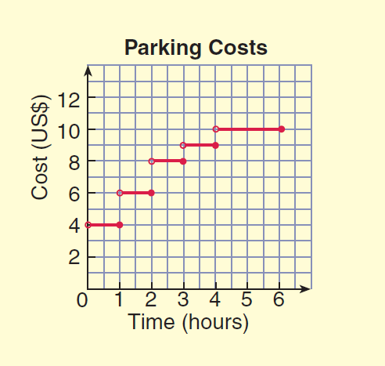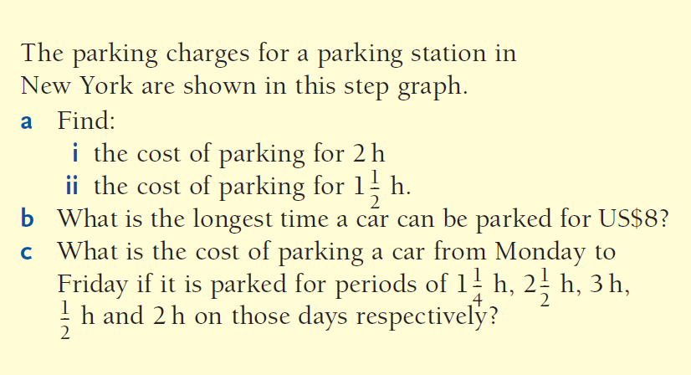

❶

**************************************************************

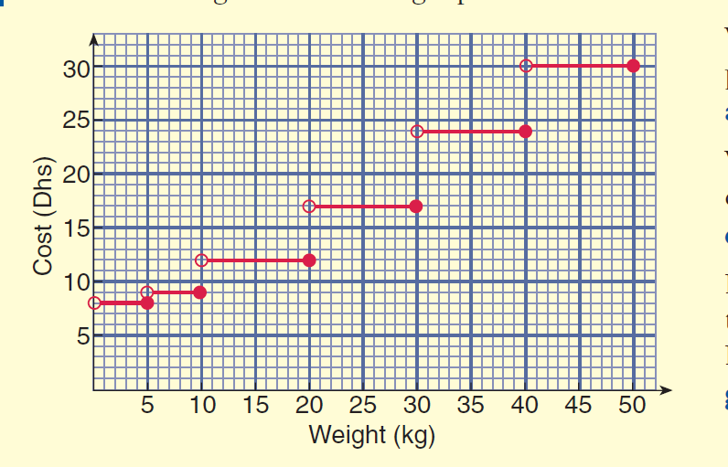

➋

❷



