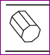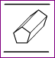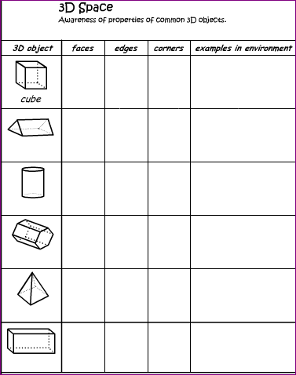

⮊ Fill in the table :

Base Sides

Edges

Vertices

Faces