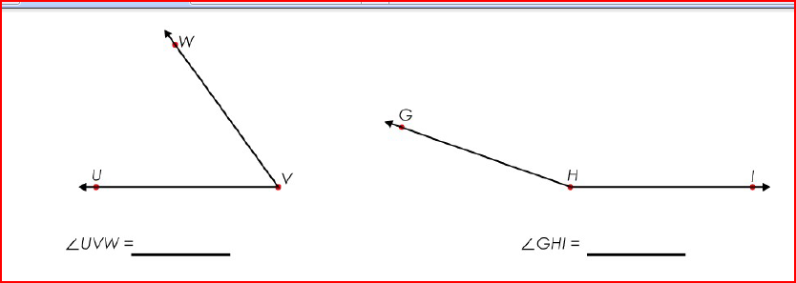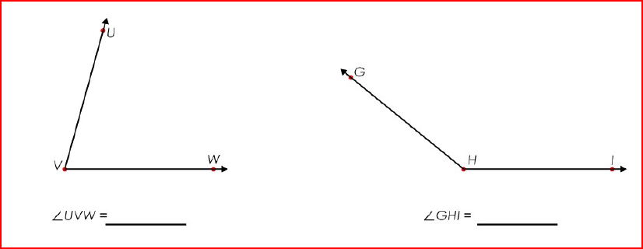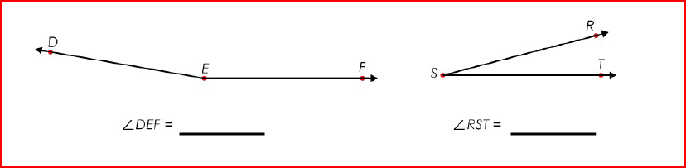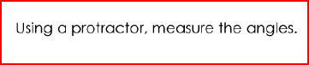[](http://www.clipart.com/en/close-up?o=3979831&memlevel=A&a=a&q=protractor&k_mode=all&s=57&e=112&show=&c=&cid=&findincat=&g=&cc=&page=2&k_exc=&pubid=)