Solids | Name | F | V | E | Working  العمل | Does Euler’s formula work? (Yes/No)
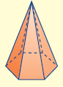

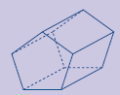

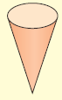

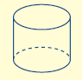
F + V = E + 2

