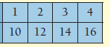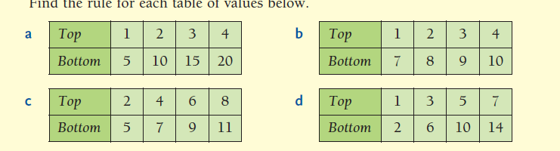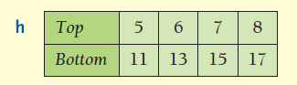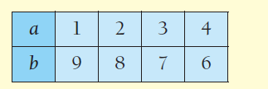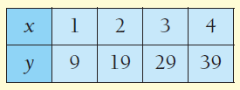

4

7

10

13

4

7

10

13

❖ Find the rule for each table of values below

**Describing Patterns**

**Describing Patterns**

❖ Find the rule for each table of values below