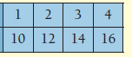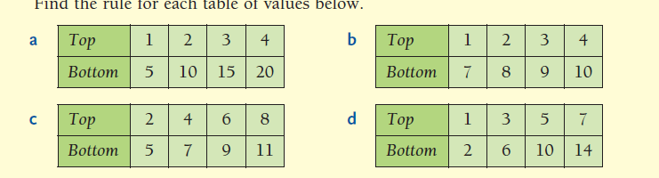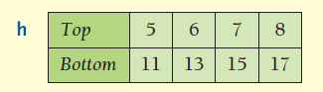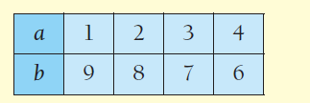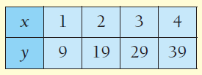

**Bottom = Top🞪 2 +1**

**Bottom = Top🞪 10 - 1**

**Bottom = Top🞪 2 +8**

**Bottom = Top🞪 3 +1**

**13**

10

7

4

4

7

10

13

❖ Find the rule for each table of values below

**Describing Patterns**

**Describing Patterns**

❖ Find the rule for each table of values below