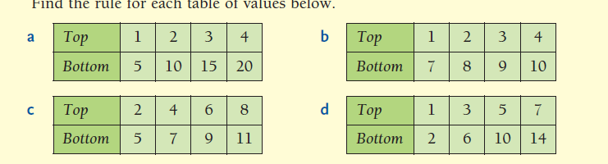

**Bottom = Top🞪 2**

**Bottom = Top + 3**

**Bottom = Top + 6**

**Bottom = Top🞪 5**

**Describing Patterns**

**Describing Patterns**

❖ Find the rule for each table of values below

❖ Find the rule for each table of values below