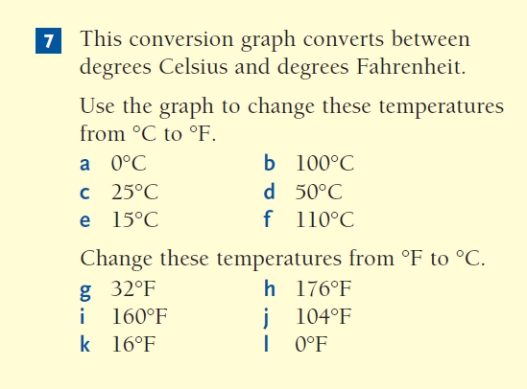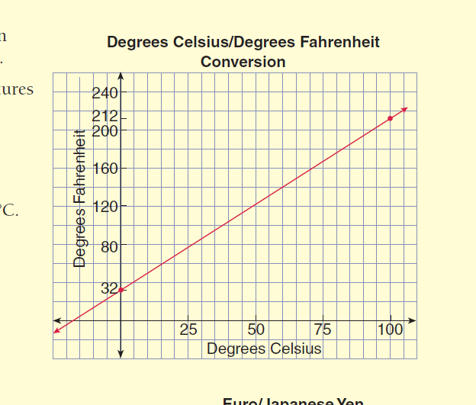[](http://images.search.yahoo.com/images/view;_ylt=A0PDoVxpbldQ9RcAjkGJzbkF;_ylu=X3oDMTBlMTQ4cGxyBHNlYwNzcgRzbGsDaW1n?back=http%3A%2F%2Fimages.search.yahoo.com%2Fsearch%2Fimages%3Fp%3Ddraw%2Bgraph%2B%2Bclipart%26n%3D30%26ei%3Dutf-8%26y%3DSearch%26fr%3Dyfp-t-742%26tab%3Dorganic%26ri%3D79&w=289&h=350&imgurl=www.clipartguide.com%2F_named_clipart_images%2F0511-0906-0919-5624_African_American_Businesswoman_Holding_a_Graph_clipart_image.jpg&rurl=http%3A%2F%2Fwww.chatham-nj.org%2FPage%2F3969&size=84.4+KB&name=Create+and+print+out+your+own+graphs&p=draw+graph++clipart&oid=22835d983e3c73eaa1adebce1b6e9688&fr2=&fr=yfp-t-742&tt=Create%2Band%2Bprint%2Bout%2Byour%2Bown%2Bgraphs&b=61&ni=96&no=79&ts=&tab=organic&sigr=113vpv8aa&sigb=13okt85ki&sigi=13vfhc558&.crumb=Yp5CYsF4dml)

❶

**************************************************************

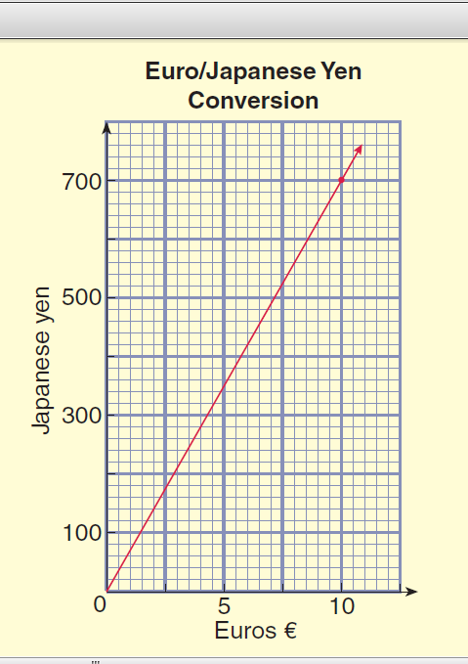

❷